TD SQL Séance 1

Exercice 2

1. SELECT * FROM PERSONNAGE ;

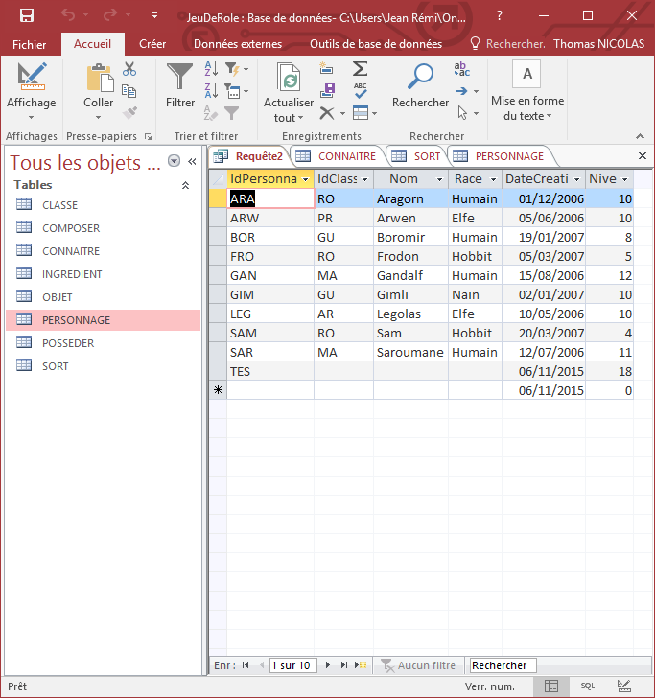

1. SELECT DISTINCT Race FROM PERSONNAGE ;

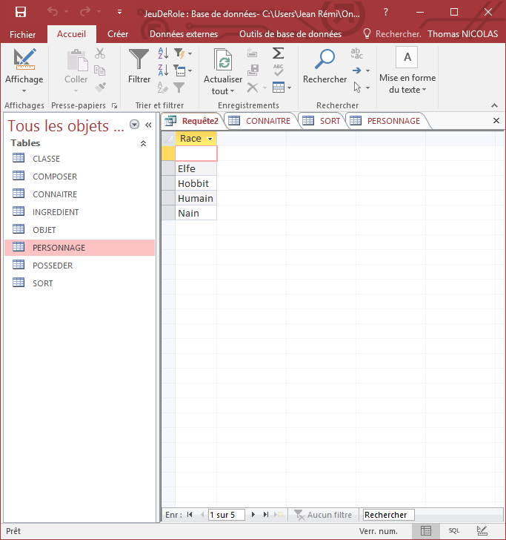

1. SELECT * FROM SORT ORDER BY IdSort DESC;

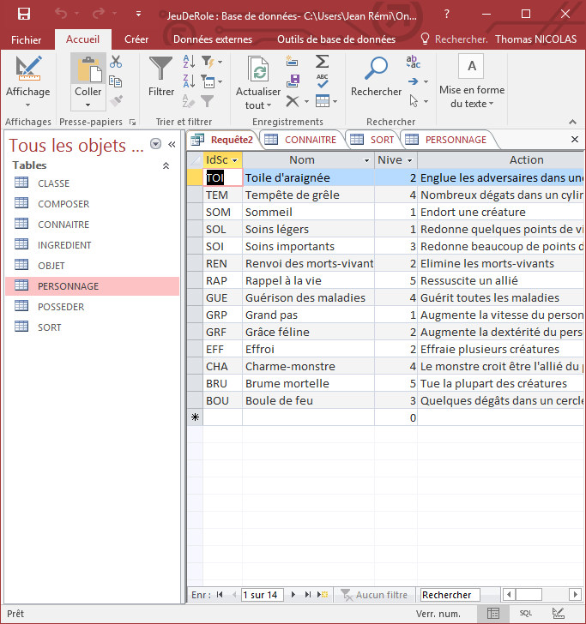

1. SELECT * FROM SORT ORDER BY Niveau DESC, Nom;

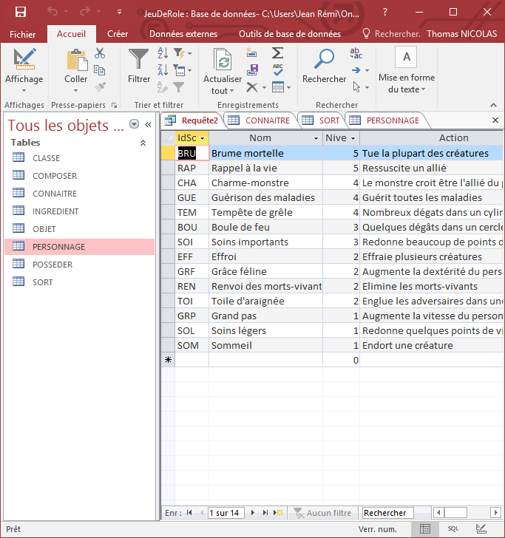

1. SELECT DISTINCT NumObjet AS Possede FROM POSSEDER;

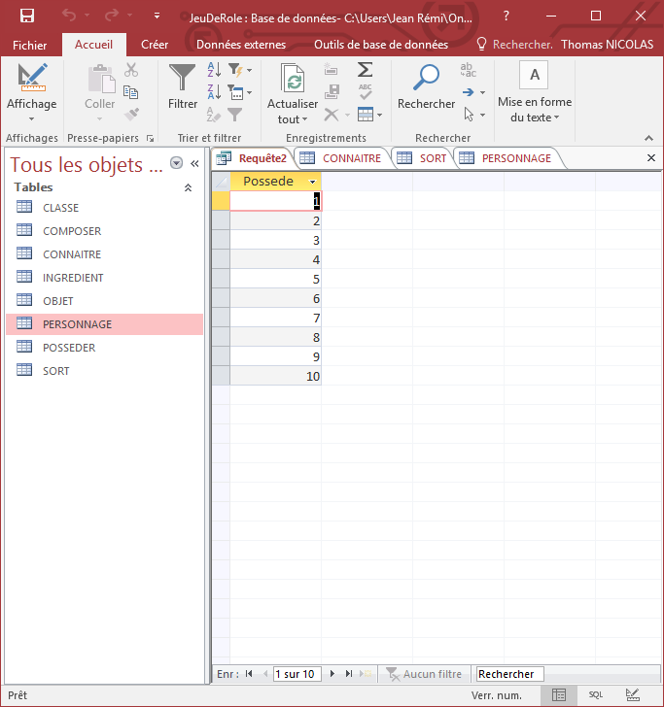

1. SELECT IdPersonnage FROM PERSONNAGE WHERE Nom IS NULL; (enregistrement rajouté à la main)

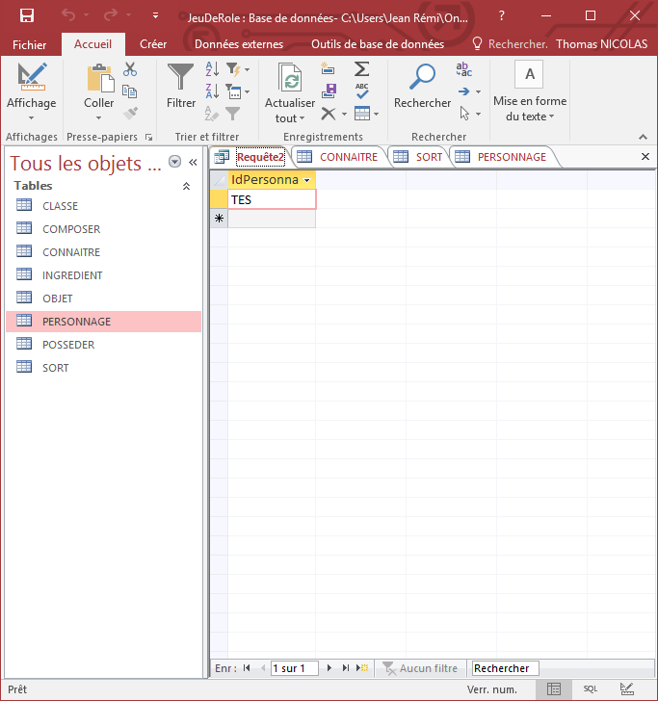

1. SELECT * FROM PERSONNAGE WHERE (Race = 'Humain') AND (Niveau <= 10) ;

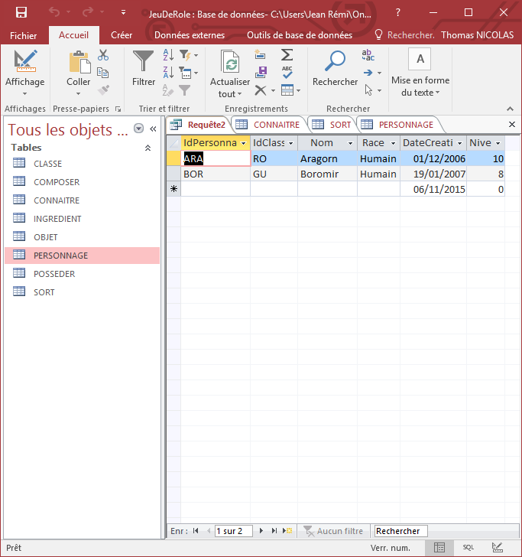

1. SELECT * FROM OBJET WHERE NOT (Categorie = 'arme');

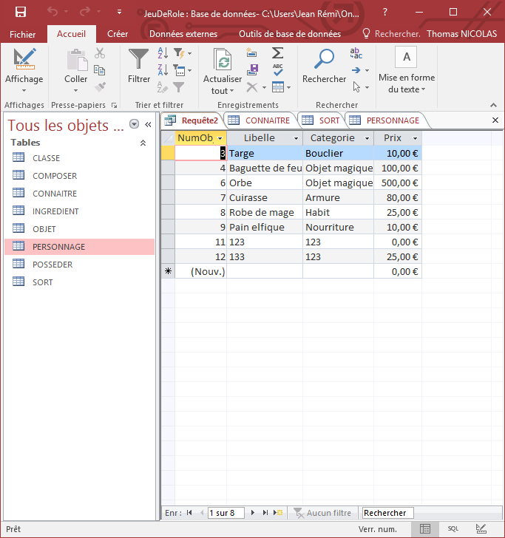

1. SELECT * FROM OBJET WHERE Categorie IN ('arme','armure');

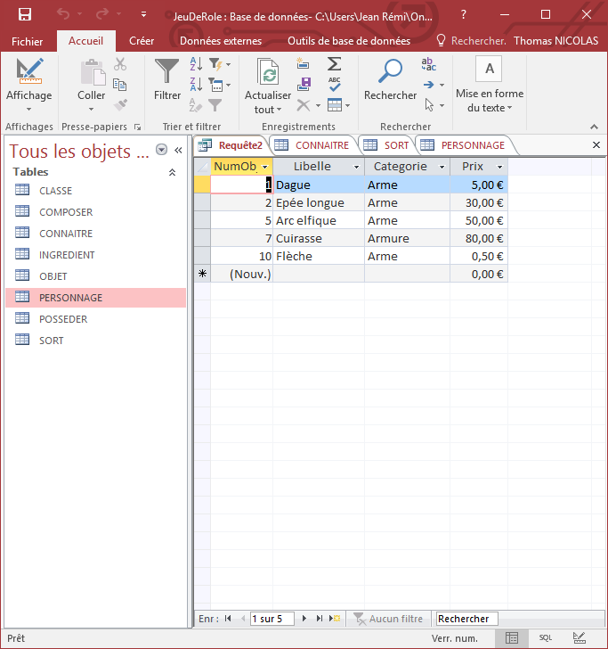

1. SELECT * FROM OBJET WHERE NOT (Categorie IN ('arme','armure'));

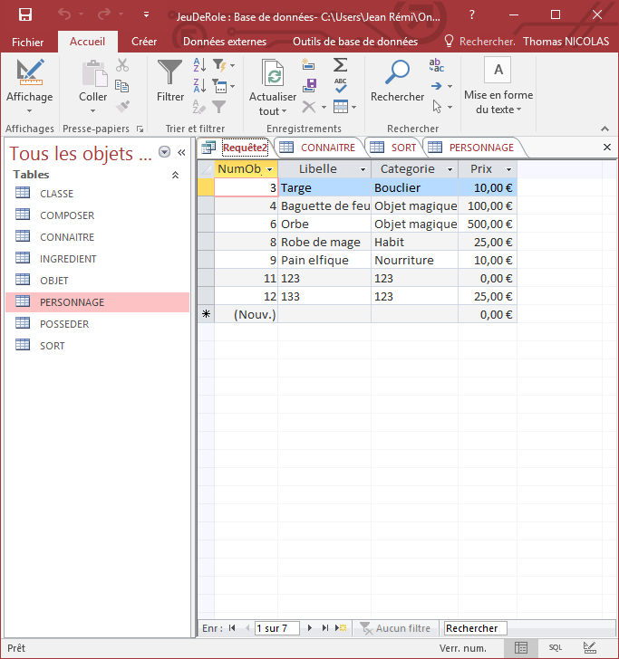

1. SELECT Libelle,Prix*1.15 & '€' AS 'Prix Majore',Categorie FROM OBJET WHERE (Categorie ='Objet Magique');

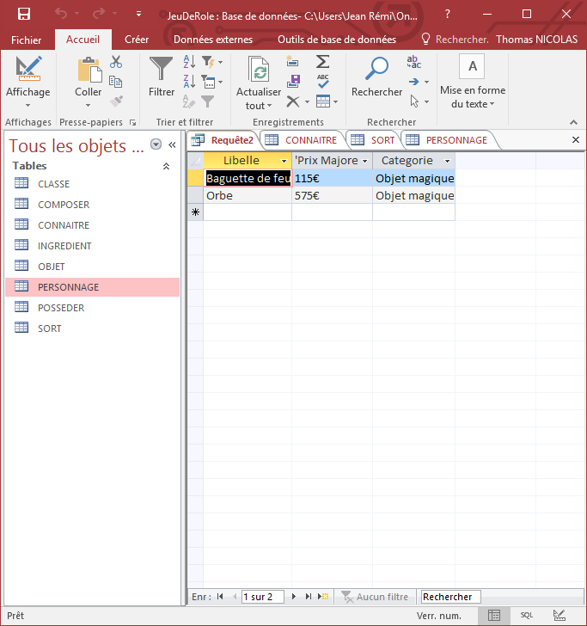

1. SELECT IdSort FROM CONNAITRE WHERE Month(DateConnu) BETWEEN 6 AND 9;

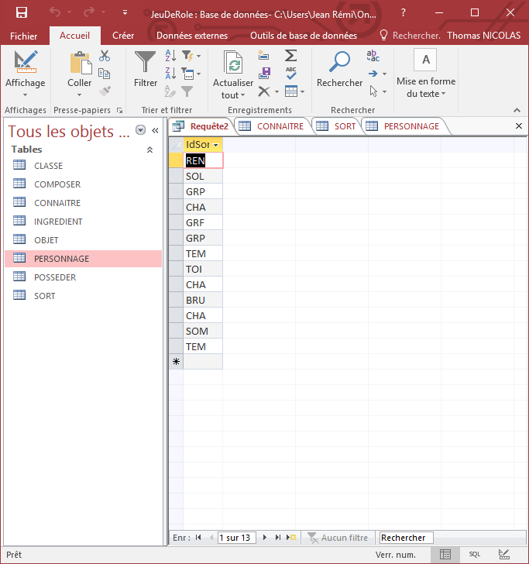

1. SELECT Nom FROM SORT WHERE Nom LIKE 'Soins*';

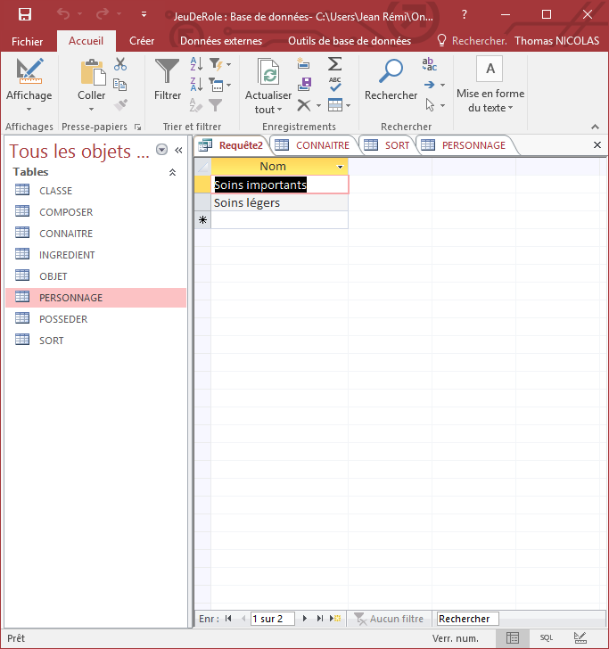

1. SELECT Nom FROM SORT WHERE Action LIKE '*dég[a,â]t*';

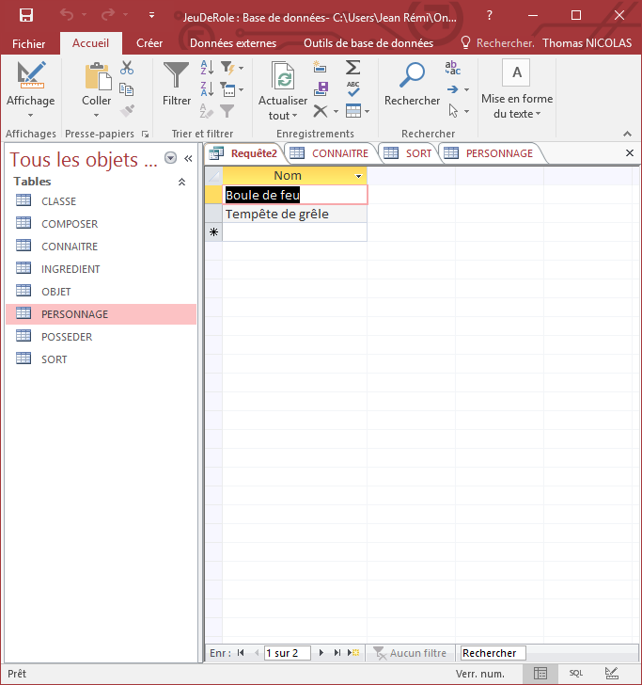

N suite ) SELECT LCASE(IdPersonnage) & '_' & IdClasse & '_' & LCASE(Nom) & '_' & LEFT(Race,1) & '_' & RIGHT(Year(DateCreation),2) AS Code FROM PERSONNAGE;

